**Bank Loan Report**

Dashboard 1 : Summary

KPIs (Key Performance Indicators)

1.Total Loan Applications

select count(id) as total_loan_applications from bank_loan_data

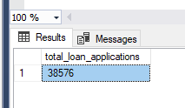

Total Loan Applications month to date

select count(id) as MTD_Total_loan_applications from bank_loan_data

where month(issue_date)=12



Total Loan Applications month over month

select count(id) as Mom_Total_loan_applications from bank_loan_data

where month(issue_date)=11



2.Total Amount Funded

select sum(loan_amount) as Total_funded_Amount

from bank_loan_data



Total Amount Funded for MTD (month to date)

select sum(loan_amount) as MTD_Total_funded_Amount

from bank_loan_data

where month(issue_date)=12



Total Amount Funded for Previous month to date

select sum(loan_amount) as PMTD_Total_funded_Amount

from bank_loan_data

where month(issue_date)=11



Total Amount Received

select sum(total_payment) as total_amount_recieved

from bank_loan_data



Total Amount Received MTD

select sum(total_payment) as MTD_total_amount_recieved

from bank_loan_data

where MONTH(issue_date)=12



Total Amount Received PMTD

select sum(total_payment) as PMTD_total_amount_recieved

from bank_loan_data

where MONTH(issue_date)=11



Average Interest Rate

select avg(int_rate)*100 as Avg_Interest_Rate

from bank_loan_data



Average Interest Rate Month to date

select round(avg(int_rate),4)*100 as MTD_Avg_Interest_Rate

from bank_loan_data

where month(issue_date)=12



Average Interest Rate PMOD

select round(avg(int_rate),4)*100 as PMTD_Avg_Interest_Rate

from bank_loan_data

where month(issue_date)=11



Average DTI Rate

select round(avg(dti),4)*100 as avg_dti_rate

from bank_loan_data



Average DTI Rate MTD

select round(avg(dti),4)*100 as MTD_avg_dti_rate

from bank_loan_data

where month(issue_date)=12



Average DTI Rate PMTD

select round(avg(dti),4)*100 as PMTD_avg_dti_rate

from bank_loan_data

where month(issue_date)=11



**Good Loan KPIs**

Good Loan Percentage

select

(count(case when loan_status='Fully Paid' or loan_status='Current' then id end)*100)

/

count(id) as Good_loan_percentage

from bank_loan_data



Good Loan Applications

select count(id) as Good_loan_applications from bank_loan_data

where loan_status='Fully Paid' or loan_status='Current'



Good Loan Funded Amount

select sum(loan_amount) as Good_Loan_Funded_Amount from bank_loan_data

where loan_status='Fully Paid' or loan_status='Current'



Good Loan Received Amount

select sum(total_payment) as Good_Loan_Funded_Amount from bank_loan_data

where loan_status='Fully Paid' or loan_status='Current'

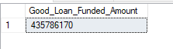

**Bad Loan KPIs**

Bad LoanPercentage

select

(count(case when loan_status='Charged Off' then id end)*100)/

count(id) as Bad_loan_Percentage

from bank_loan_data



Bad Loan Applications

select count(id) as Bad_Loan_Applications from bank_loan_data

where loan_status='Charged Off'



Bad Loans Funded Amount

select sum(loan_amount) as Bad_Loan_Amount from bank_loan_data

where loan_status='Charged Off'



Bad Loans Received Amount

select sum(total_payment) as Bad_Loan_Recieved_Amount from bank_loan_data

where loan_status='Charged Off'



Loan Status Grid View

select

loan_status,

count(id) as Total_Loan_Applications,

sum(total_payment) as Total_Amount_Recieved,

sum(loan_amount) as Total_Funded_Amount,

avg(int_rate*100) as Interest_Rate,

avg(dti*100)as DTI

from bank_loan_data

group by loan_status

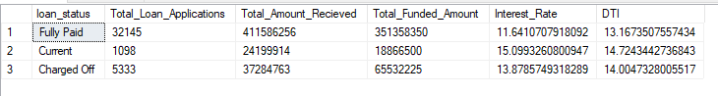

select

loan_status,

sum(total_payment) as MTD_Total_Amount_Recieved,

sum(loan_amount) as MTD_Total_Funded_Amount

from bank_loan_data

where month(issue_date)=12

group by loan_status

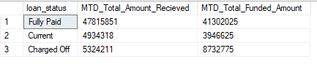

**Dashboard 2 : Overview**

**1. Monthly Trends by Issue Date (Line Chart):**

select

month(issue_date) as Month,

datename(month,issue_date) as Month_Name,

count(id) as Total_Applications,

sum(loan_amount) as Total_funded_Amount,

sum(total_payment) as Total_Recived_amount

from bank_loan_data

group by datename(month,issue_date),month(issue_date)

order by month(issue_date)

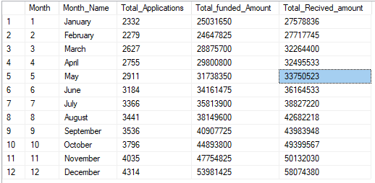

**2.Regional Analysis by State**

select

address_state,

count(id) as Total_Applications,

sum(loan_amount) as Total_funded_Amount,

sum(total_payment) as Total_Recived_amount

from bank_loan_data

group by address_state

order by address_state

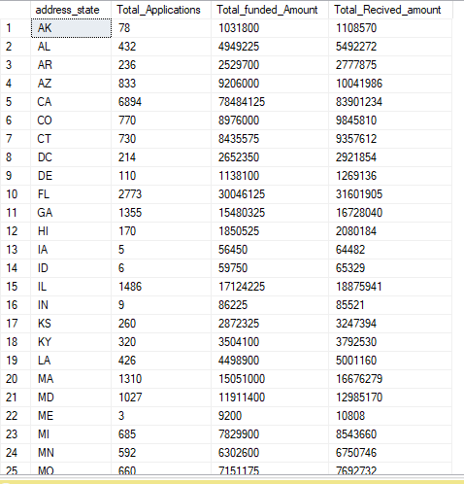

**3. Loan Term Analysis (Donut Chart):**

select

term,

count(id) as Total_Applications,

sum(loan_amount) as Total_funded_Amount,

sum(total_payment) as Total_Recived_amount

from bank_loan_data

group by term

order by term desc

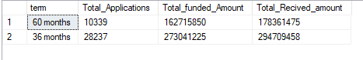

**4. Employee Length Analysis (Bar Chart):**

select

emp_length,

count(id) as Total_Applications,

sum(loan_amount) as Total_funded_Amount,

sum(total_payment) as Total_Recived_amount

from bank_loan_data

group by emp_length

order by emp_length

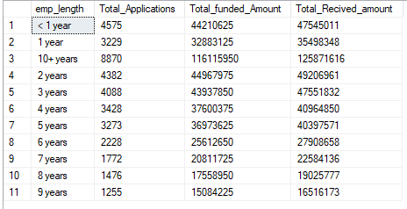

**5. Loan Purpose Breakdown (Bar Chart):**

select

purpose,

count(id) as Total_Applications,

sum(loan_amount) as Total_funded_Amount,

sum(total_payment) as Total_Recived_amount

from bank_loan_data

group by purpose

order by purpose

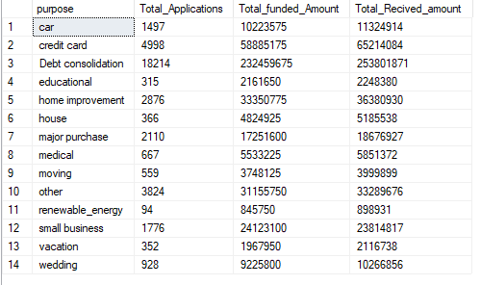

**6. Home Ownership Analysis (Tree Map):**

select

home_ownership,

count(id) as Total_Applications,

sum(loan_amount) as Total_funded_Amount,

sum(total_payment) as Total_Recived_amount

from bank_loan_data

group by home_ownership

order by home_ownership

